**IS3S661 Tutorial: Strategy Initiation**

**Q.1 What is the difference between a Vision Statement and a Mission Statement?**

Organisations summarise their goals and objectives in mission and vision statements. Both of these serve different purposes for a company but are often confused with each other. While a mission statement describes what a company wants to do now, a vision statement outlines what a company wants to be in the future.

The ***Mission Statement*** concentrates on the present; it defines the customer(s), critical processes and it informs you about the desired level of performance.

The ***Vision Statement*** focuses on the future; it is a source of inspiration and motivation. Often it describes not just the future of the organisation but the future of the industry or society in which the organisation hopes to effect change.

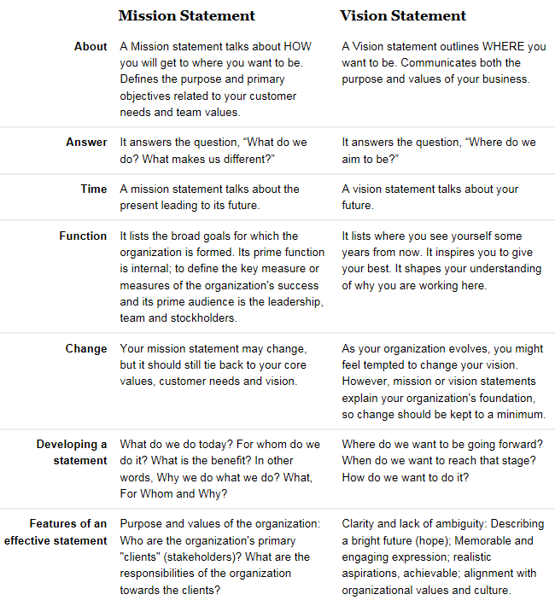

**Source: http://www.diffen.com/difference/Mission_Statement_vs_Vision_Statement**

**Q.2 For the companies below, identify their (i) VISION, (ii) MISSION STATEMENT, and optionally (iii) CORE VALUES**

1. **Microsoft**
2. **Amazon**
3. **Tesco**
4. **Google**
5. **Apple**
6. **eBay**
7. **Yahoo**

**Q.3 In respect of Q.2, have any of these changed substantially in recent years?**

**Q.4 “The American Declaration of Independence was probably the best Mission Statement of all time” (Anon). Can you identify 3 or 4 examples of other good Mission (or Vision) Statements?**

**Q.5 Can you identify 3 or 4 examples of bad Mission (or Vision) Statements? (e.g. check out Virgin Atlantic, Cadbury-Schweppes).**

**Q.6 For ONE of the companies in Q.2, identify the strength of Porter’s 5 Forces which you think that company faces.**

